[**Lab 4 10/01/14**](https://rccdopencampus.blackboard.com/webapps/blackboard/execute/uploadAssignment?content_id=_1759112_1&course_id=_22731_1&assign_group_id=&mode=view)

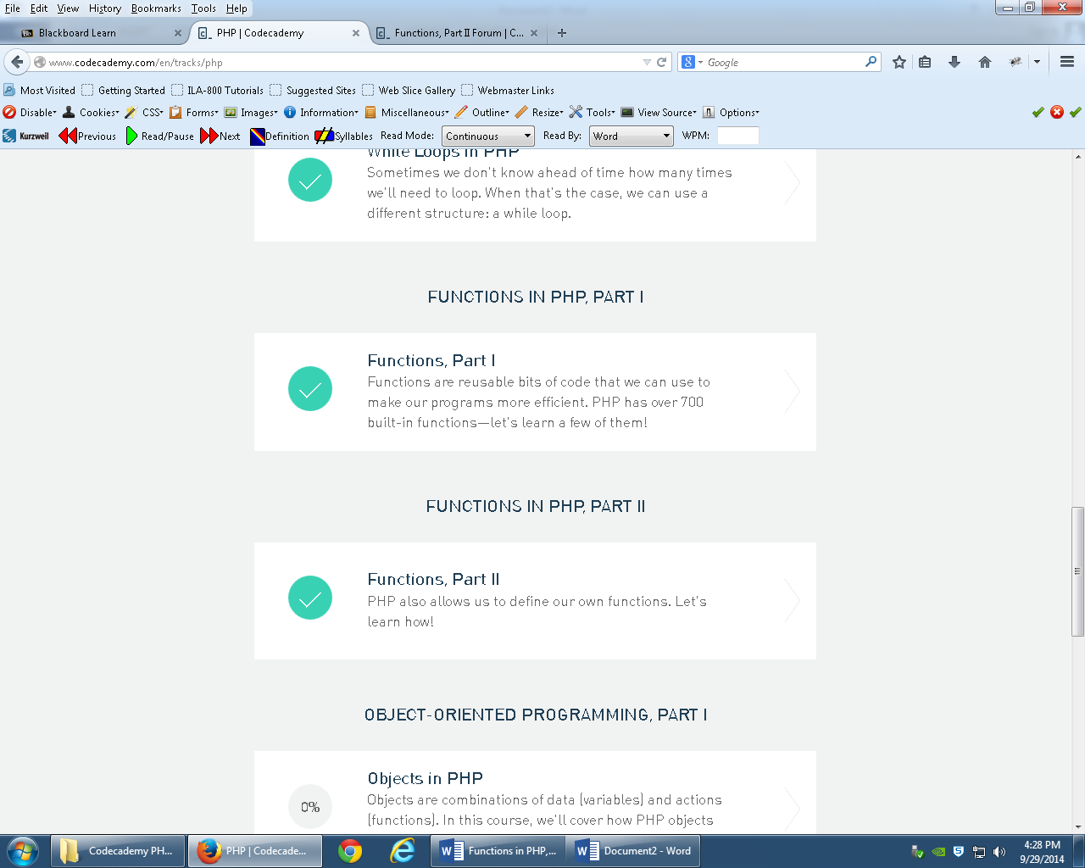Sections 7 and 8